|  |  |
| --- | --- |
| REPORT FOR: | HEALTH AND WELLBEING BOARD |
| Date of Meeting: | 10 January 2019 |
| Subject: | Social Prescribing Position paper |
| Responsible Officer: | Joint Report Javina Sehgal , Managing Director Harrow CCG and Carole Furlong Director of Public Health Harrow Council. |
| Public: | Yes |
| Wards affected: | all |
| Enclosures: | Appendix 1- Social Prescribing Models  Appendix 2 – Social Prescribing Interventions  Appendix 3 – Adult Social Care Vision |

|  |
| --- |
| Section 1 – Summary and Recommendations |
| This report sets out the context and the evidence for Social Prescribing. It has been developed using information from different sources including a number of engagement events and work on developing resilient communities held by the LA. It has culminated in a Task and Finish Group working across the LA and CCG, supported by a wider Community Resilience group working across Harrow. This paper details the Social Prescribing Strategy for Harrow within the context of a wider Community Based Asset Development approach. Recommendations: The Board is requested to:   * Support the development of an in house social prescribing coordination for Harrow as outlined and request quarterly briefings on the progress * Note the interim funding agreed by the CCG and Council for the continuation of the current Social Prescribing service Healthwise run by Capable communities to 31st March 2019. Note that this service was not funded by the Council or CCG previously but as its current funding from other sources runs out in December 2018. |

# Section 2 – Report

## What is Social Prescribing?

In its simplest form, social prescribing is a method for the health professional to prescribe a structured social activity to a patient with wider social, emotional or practical need which cannot be met by clinical or social care services.

The rationale for this is that health is determined by social, economic and environmental factors and adding social prescribing as another tool in additional to clinical and social care allows a more holistic approach to support patients to manage and take greater control of their health.

Without this support, patients may frequently attend primary care and their health may be further compromised resulting in need for secondary care. It is estimated that around 20% of patients consult their GP for what is primarily a social problem with 15 % of GP visits for social welfare advice. We do not know how much of the demand on front line social workers can be reduced by social prescribing as similar information from social care services is not yet collected. However, one can envisage that loneliness, social isolation, carers’ wellbeing are factors that do impact on social care.

The social needs of people can vary from being socially isolated due to limited mobility or carer responsibility, loss of their purpose and meaning of life due to bereavement or retirement, financial challenges due to loss of income. Therefore, a range of structured activities need to be in place for social prescribing to be effective. The prescriptions can include referrals to a variety of services/activities such as arts, volunteering, physical exercise, such as gardening and dance clubs, and/or referring to services that offer advice to debt, benefits and housing.

Social prescribing is a tool for health promotion. Health promotion is the process of enabling people to increase control over, and to improve, their health. To reach a state of complete physical, mental and social wellbeing, an individual or group must be able to identify and to realise aspirations, to satisfy needs, and to change or cope with the environment. Health is, therefore, seen as a resource for everyday life, not the objective of living.

## What is the Evidence that Social Prescribing works?

A systematic review[1] of the evidence assessing the impact of social prescribing on healthcare demand and cost implications showed average reductions following referral to social prescribing of 28% in GP services, 24% reduction in attendance at A & E and statistically significant drops in referrals to hospital. A systematic review of social prescribing literature was broadly supportive of its potential to reduce demand on primary and secondary care. The quality of that evidence is weak, and without further evaluation, it would be premature to conclude that a proof of concept for demand reduction had been established. Similarly, the evidence that social prescribing delivers cost savings to the health service over and above operating costs is encouraging but by no means proven or fully quantified. Studies have pointed to improvements in areas such as quality of life and emotional wellbeing, mental and general wellbeing, and levels of depression and anxiety.

One has to remember, that social prescribing projects grew from the need recognized by primary care and were not set up as research projects to collect data. The best example of such a project is the Bromley- by –Bow Centre which has been a successful project. A number of social prescribing projects are now collecting data.

Early results from pre and post analyses from the Merton[2] social prescribing found

* 18% reduction in A& E attendance with a 32% reduction in cost
* 30% reduction in emergency admissions with 56% reduction in cost
* 20% increase in planned (elective) admissions with an increase of 10% cost
* 14% reduction in outpatients with 22% reduction in costs

The evaluation[3] of Rotherham social prescribing service included a similar before and after analyses and at 6 and 12 months (different cohorts) they found the following results:

* 14% and 21% reduction in inpatient admissions
* 12% and 20% reduction in A&E attendance
* 15% and 21% reduction in outpatient attendance

The Rotherham evaluation also measured the progress in feeling positive, self-care and managing symptoms, life style, social connections. The largest benefits were found amongst those that had the lowest score with the following proportion of people making progress:

* 61% feeling positive
* 60% showing improvement in self care
* 57% managing symptoms
* 54% improving social connections
* 76% reporting financial improvement

The Tower Hamlets social prescribing service evaluation[4] found that the there was a reduction in the MyCaW[5] Scores at 12 weeks. The MyCaW is a tool that is designed for patients to decide which 1-2 concerns/problems they want to be supported on (e.g. pain, debt) and score from 1-6 how much that concern bothers them before and after support.

There is general consensus that any social prescribing service or pilot needs to have robust evaluation built in from the start.

## What do we know about Models of Social Prescribing?

There are different models of social prescribing. Models range from a referral (prescribing) from primary care services to a link worker to building on asset based social capital and health generating models. More advanced include a combination of both. They can also differ in what is offered. The reason for such variation is that social prescribing is based on local needs. Some models and examples are provided below:

1. A mainly sign posting offer with a facilitator (care navigator or link worker) signposting people to appropriate services/activities in the community. In this case the facilitator acts as a bridge between primary care and the community. In some cases, this happens within primary care where a healthcare assistant is trained to be a social prescriber.
2. A prescriptive service with free structured interventions (8-12 weeks) to support people to build the skills/resilience to manage/overcome the main cause that triggered referral with follow up for 12 months. An example of this locally would be the Expert Patient Programme and the Exercise On Referral programme. This may be complimented by signposting to other services/activities of which some may be chargeable.
3. An asset based approach service with a combination of 1, 2 and further building capacity within communities for health improvement.

Examples of different social prescribing models are given in appendix 1. All schemes have a facilitator/care navigator or social prescriber embedded in GP practice, voluntary sector, or council. They can be employed by any one organisation and be trained in motivational interviewing skills.

## How does Social Prescribing Fit with current Policy Frameworks?

There has been an interest in social prescribing from the ground for many years and now it is included in different policy /strategy documents nationally as listed below

* Social prescribing is one of the main interventions in the Prime Minster’s Strategy to tackle loneliness- Connected Societies (2018). There is an expectation that every GP surgery across the country will be able to offer social prescribing by 2023
* The Department of Health and Social Care announced a fund to invest in social prescription and 23 projects across England were funded through this scheme in 2018.
* The Ministry of Housing, Communities and Local Government has funded £3.3 million Communities Fund, for partnerships to deliver social prescribing interventions to help tackle loneliness amongst the elderly and young people.
* The NHS forward view (2014) and the GP Practice Forward View (2016)
* The Local Government association has published guidance on social prescription for local authorities
* It is expected that the NHS long term plan to be published will also have social prescribing as one of the key areas of action.

## Current situation

Currently the CCG and Council do not commission a social prescribing service in Harrow. However, there are a number of services that health and care professionals can make referrals for wider social and life-style needs of their patients and clients.

The Council runs and funds a number of activities which are suitable for social prescribing and referrals are received from various frontline services.

|  |  |
| --- | --- |
| * Expert patient Programme (EPP) trained volunteers who run 6 weeks course on chronic disease self –management | The Expert Patients Programme (EPP) is a free course is for people who are living with any long-term health condition and/or their carers. It is run by tutors who are also living with long term conditions and will help and support them to manage their conditions more effectively. Courses run for 6 weeks, once a week for 2.5 hours including a 20minute break. All courses have 2 tutors working together as co-tutors. The maximum amount of people on an EPP course is 16 and the minimum 6. It is run at Wealdstone centre |
| * Healthy walks | 50 trained health walkers supporting at least 1 walk per day every week for people of all levels of fitness and abilities (walks also suitable for people in wheel chair)  Last year about 350 new walkers joined the walks in Harrow |
| * Exercise on referral | This is integrated in the contract with Everyone Active |
| * Books on prescription and reading well initiative | Available through libraries |
| * Training and capacity building | MHFA training  Oral Health training  Busy Feet |
| * Coordination and support for Healthy Schools and Healthy Early Years Programmes |  |
| * Wiseworks | a local mental health pre-vocational work centre provided by the Disability Day Services of Harrow Council. For more than 25 years, the service has worked with people recovering from mental health problems by assessing their work skills, providing comprehensive work rehabilitation and arranging training at local colleges. |
| * Adult and Family learning (learnharrow.ac.uk) | Wellbeing courses – dance and drama therapy, confidence building arts, yoga (these are about £5 for the full course 8-12 weeks)  Skills based courses e.g sewing , book keeping, music, cake decorating , excel  English language classes, family (intergenerational classes) and courses for parents  Harrow learning participated in the community mental health research project. The findings from the research found that The Community Learning Mental Health (CLMH) research project aimed to identify the potential for adult and community learning courses to help people develop the tools, strategies and resilience to manage, and aid recovery from, mild to moderate mental health problems, such as anxiety and depression. This project was designed to build on the existing evidence base supporting the impact of adult and community learning on mental health and wellbeing. **The research reported that 55% of people with common mental health problems such as depression and anxiety that attended the courses at the Learn Harrow showed indications of recovery.** |

In June 2017, Capable Communities, received a grant of £69K for 18 months for a social prescribing service- Healthwise. There was expectation that Healthwise would generate income to make the service sustainable. Healthwise has requested funding from CCG and the Council as its current funds including income generated will run out in December 2018.The CCG and Council considered this request as a one off funding of £15K to support the service to March 2019.

According the information received from Capable Communities, for the period June 2017 to December 2018, Healthwise provided access to services across three categories:

* 38% Rights – accessing information, advocacy and advice - mainly housing and welfare benefits
* 34% Health – healthy eating (20%), managing diabetes and /or hypertension (12%), dementia (2%) and falls prevention (1%)
* 28% Wellbeing – reducing isolation, purposeful activities.

Table 1 highlights the type of activity and number of users that Healthwise engaged (the total number has been revised to 4867 but no breakdown of sessions /users is available).

Table Sessions run and number of users engaged (referred?)

|  |  |  |
| --- | --- | --- |
| Activity | Sessions | Number of users engaged |
| Dementia Activity Sessions | 76 | 26 |
| Falls prevention Sessions | 72 | 46 |
| Healthy Living Group Sessions | 75 | 56 |
| EPP General sessions | 6 | 17 |
| EPP diabetes sessions | 8 | 17 |
| Health Eating Session | 220 | 421 |
| BP checks | 12 | 157 |
| Walk sessions | 700 | 74 |
| Dementia 3R | 16 | 45 |
| Subtotal |  | 859 (807 individuals?) |
| Signposting | 1744 | 2002 |

Around 807 individuals engaged in different sessions and of these, around 700 reported improved scores on the STAR tool.

The information from the project commissioned by Adult Social Care on mapping voluntary and community care services as part of building resilient communities found that there are around 800 voluntary and community organisations in Harrow providing a different range of services that support residents. Many of these may be offering interventions/activities suitable for social prescribing and some are already included in the signposting list from Healthwise.

## What is the Size of Population that could benefit?

The ONS mid-year estimate for adult population in Harrow was 189.5 K. Figure 1 below shows the age structure of the adult population. 10% of the population is in the transition stage age of 19-25 years and 10% is 75 + years. Social prescription services required for these two groups will be very different. Figure 2 shows the diversity in Harrow that indicates a need for cultural perspective

Figure Age structure of adult population in Harrow (2018)

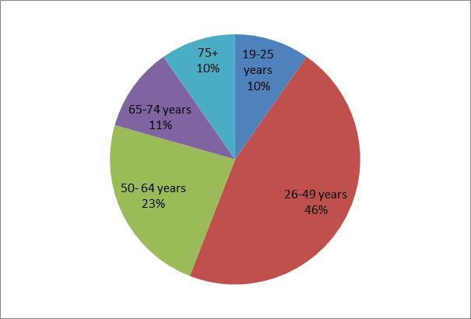

Figure Ethnic breakdown of adult population in Harrow (2018)

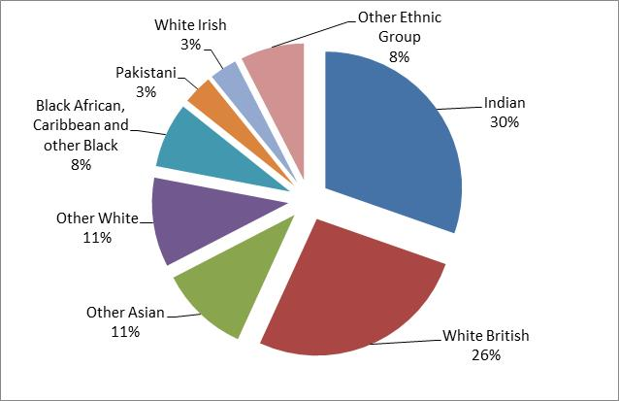

The following figure and tables show that there are a large number of people with different long term conditions who may benefit from a social prescription. Many of these people will have multiple conditions so the categories are not mutually exclusive.

Figure The potential cohort size of people with different conditions that are suitable for a social prescription

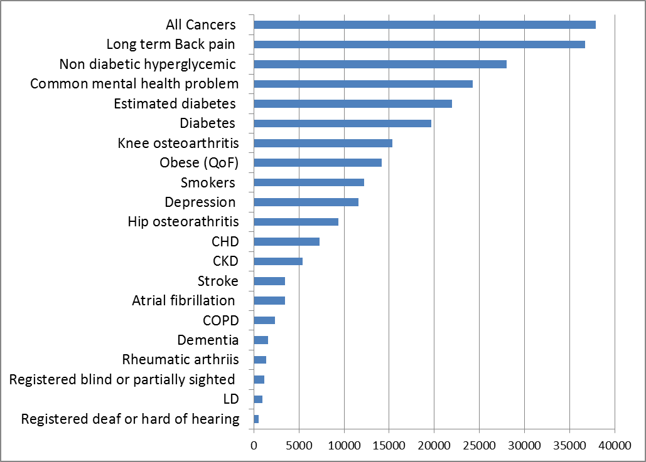

Source: Produced from various profiles on PHE fingertips 2018

Table Number of people registered as sight impaired/blind in Harrow between 1st April 2016 to March 2017

|  |  |
| --- | --- |
| Type of Sight Impairment |  |
| Blind/severely sight impaired adults (registered) | 665 |
| Partially sighted/ sight impaired adults | 539 |
| Slightly sight impaired adults with an additional disability | 304 |
| Registered partial sighted /sight impaired adults with additional disability | 276 |

(SOURCE: SALT Statutory Social Care data return, 2016-17, the latest data available – collected every 3 years)

Table People with learning disability of working age (16-64 years) by employment status (2017/2018)

|  |  |  |  |  |  |  |
| --- | --- | --- | --- | --- | --- | --- |
| Gender | In employment | | Not in paid employment | | Unknown | Total |
|  | less than 16 hours | 16 hours or more | Seeking work | Not actively seeking work/retired |  |  |
| Males | 53 | 2 | 4 | 241 | 0 | 300 |
| Females | 38 | 0 | 2 | 181 | 0 | 221 |
|  | 91 | 2 | 6 | 422 |  | 521 |

Source: SALT Statutory Social Care data return, 1st April 2017- March 2018.

Table Profile of 2018 social service user survey 2018

|  |  |
| --- | --- |
|  |  |
| Gender | 44.1% men and 55.9% women |
| Age | 57.6 % under 65 years and 42.4% over 65 years of age |
| Needs | 18.6 % access and mobility issues |
| 40.7% personal care needs |
| 11.9% had learning disability |
| 28.8% had mental health problems |

The 2018 Social Care User Survey was sent out to all 1995 users of social care in Harrow and 505 responded. The survey included a question on social isolation. Of those who responded, 29% reported being socially isolated and 22% said they did not find ways to spend their time as they would like.

## Areas of gaps

Whilst there are components within Harrow that would be useful for social prescribing there is a need to develop a social prescribing pathway at scale.

## What Outcomes would be achieved at population level?

One of the key aims of the social prescribing service is to empower the person to manage the social issue and look after their own health, thus reducing reliance and therefore cost across the health & social care sector. As a result the outcomes may be more personalised, however at population level some of the outcomes can be measured such as

* loneliness,
* health and care service use,
* reduction in symptoms/prevalence
* recovery and rehabilitation,
* quality of life

To provide some indications of the impact of social prescribing in Harrow data from the social prescribing modelling commissioned by Healthy London partnership (HLP) for all boroughs in London is presented in this paper.

The modelling used secondary care activity data (SUS data) to model the number of people who were seen in secondary care (planned and unplanned activity). It used a number of evidence-based interventions to estimate the reduction in secondary care based on average secondary care service use.

Table 5 shows the potential reduction based on the cohort of secondary care users in 2016/2017. The cohort of population was those that had outpatient and inpatient activity, had between 0-2 days length of stay, which are not complex and do not require specialist services. In brief activity that can be defined as avoidable. National tariffs were then applied to these avoidable activities to estimate reduction in costs. The cost of social prescribing service was calculated as 150-200k per year. The table shows the total current costs (both avoidable and non-avoidable) in 2016/2017 and that which could have been avoided with social prescribing. The model can then be used to forecast future reductions.

Table Modelled opportunities for reduction in avoidable secondary care costs in 2016/2017



Appendix 2 shows the modelled reduction by practice level. The practices with larger list size and older population are likley to see the greatest benefits to their patients from these interventions.

## What are the Options for Harrow?

In line with national strategy Harrow will need to implement a social prescribing offer to all GPs by 2023. In addition, it has to be at a scale that all patients that can benefit can be given a social prescription.

To do so, there are a number of innovations to social prescribing that may need to be introduced in line with some of the innovative integration processes already happening in Harrow

* A shift away from GP attendance for social prescribing referral to pharmacy and social worker referrals into SP.
* It should build capacity within communities using an assets based approach to build resilience
* It should be an inclusive service enabling people to undertake activities together (irrespective of physical or mental health conditions) free of charge to the patient.
* Patients needs to followed through the pathway with clear outcomes and follow up data collated and fed back to referrer
* Evaluation needs to be build from the start in the programme.
* It needs to be part of integrated services in future

To deliver a prototype service model that is cost-effective in delivering long-term benefits to the population of Harrow the following options have been considered.

### Option 1: Commission the current Healthwise social prescribing services after March 2019.

Advantage: The service is already set up and has clients

Limitations: The service is depended on other services provided by the council such as Expert Patient Programme, Healthy Walks, cookery, adult learning classes being run and will require additional monies to expand it to cover other interventions. The outcomes are not clearly defined in relation to the at risk groups.

Financials: Cost per year £292K is requested by Healthwise from CCG and Council to run a social prescribing service

### Option 2 Develop a service specification and procure a social prescribing service.

Advantage: Allows the partners to write a specification to meet the needs in Harrow and test market for providers

Limitations: This will require a commissioning process from a fuller understanding of needs (from both health and social care services), gap analyses and interventions directory to meet those needs. The time and cost associated with this approach needs to be factored into the overall project cost and feasibility.

Financials: To be determined from requirements

**Option 3**

Develop and test a prototype in-house in 2019/2020

Advantages: The programme will be closely linked to delivery against health and social care needs.

It builds on the success of the coordination and delivery of existing programmes such as healthy walks; EPP programme; adult learning programmes and offers the ability to restock the books on prescription.

The programme is aligned and can link with other current plans in the council and CCG. These include :-

* The adult social care is developing the community resilience vision (appendix 3) that includes developing a digital directory.
* The cultural strategy offer of increasing participation
* CCG health and care integration care pathway modelling and a “one click” referral from EMIS (GP system) for social prescribing and feedback to the GP .This is one of the criticisms of current system.

Limitation: The programme relies on the delivery of a digital directory.

There may be reluctance to engage by existing providers of Healthwise services.

Financials: This would require 1.0 FTE at G7 and 0.5 admin at G3 in public health team to coordinate and monitor the social prescribing service. There will be a requirement to train health and care frontline workers on the Social Prescribing pathway. Health Education England may be approached for funding this training or it can be funded by CCG and adult social care with the training provided by public health.

Additional costs associated with the delivery of programmes need to be factored in.

The CCG and Council share the costs with CCG providing the software and training to practices and the public health team providing the coordinator and administration.

### Recommendation: We recommend Option three and ask the Board to support this decision.

## Implications of the Recommendation

Option 3 is recommended so that the current services can be utilised effectively for developing a local evidence based social prescribing pathway. This will allow integration of other wider local authority services for better health and wellbeing outcomes with the current health and care integration.

### Resources, costs and risks

As a prototype programme, we will initially work with two or three practices and the voluntary sector to develop and test the new model of delivery in 2019/2020. We will then roll out to all practices in line with national strategy in 2020. We have been in discussion with Healthy London partnership to support the modelling of activity costs and reductions in social care costs during the prototype. Healthy London partnership will be part of the working group on the prototype.

### Staffing/workforce

This would require 1.0 FTE at G7 and 0.5 admin at G3 in public health team to coordinate and monitor the social prescribing service.

There will be a requirement to train health and care frontline workers on the Social Prescribing pathway. Health Education England may be approached for funding this training or it can be funded by CCG and adult social care with the training provided by public health.

### Equalities impact

This service should be accessible to all residents that meet the criteria that will be developed for Social Prescribing in Harrow for prototype. It is expected that those with Long term conditions and are socially isolated will benefit the most. A full EQIA will be undertaken as the model is developed.

### Community safety

No implications identified.

## Financial Implications

The costs of the preferred option to develop and test a prototype are expected to be in the region of £103K in a full year. This will be funded by both the local authority (approx. £53.5k for staffing costs associated with co-ordination and monitoring) and the CCG (approx. £50 K for software and training). The staffing costs will be contained within the existing 2019/20 Public Health budget.

In all options, there is an expectation the current programmes contributing to the social prescribing model that are funded by the council or CCG will continue at their current level. (e.g. Adult learning; Exercise on referral; EPP).

Any wider adoption of the social prescribing model beyond 2019/20 will need to be considered by each partner organisation as part of its annual budget setting process, supported by a business case which identifies the required level of investment and which clearly sets out the return on investment i.e. the ability to reduce health and social care costs across the partnership.

**Legal Implications/Comments**

(If any)

## Risk Management Implications

Identify potential key risks and opportunities associated with the proposal(s) and the current controls (in place, underway or planned) to mitigate the risks.

## Equalities implications

Was an Equality Impact Assessment carried out? /No

The EqIA will be carried out as part of the evaluation in the prototype

## Council Priorities

The Council’s vision:

**Working Together to Make a Difference for Harrow**

* Making a difference for the vulnerable

This paper sets out a service which will benefit by meeting the wider social needs of those that are vulnerable by providing opportunities to connect, add meaning and purpose and learn.

* Making a difference for communities

This paper sets out a service which provides health and wellbeing improvement opportunities for communities

* Making a difference for local businesses
* Making a difference for families

As found in the research from the adult learning services , family learning opportunities provide intergenerational opportunities to improve wellbeing

# Section 3 - Statutory Officer Clearance (Council and Joint Reports)

|  |  |  |  |
| --- | --- | --- | --- |
|  |  |  | on behalf of the |
| Name: Usha Chauhan | x |  | Chief Financial Officer |
| Date: 2 January 2019 |  |  |  |
|  |  |  | on behalf of the |
| Name: Sharon Clarke | x |  | Monitoring Officer |
| Date: 3 January 2019 |  |  |  |

|  |  |
| --- | --- |
| Ward Councillors notified: | **NO** |

# Section 4 - Contact Details and Background Papers

**Contact:**

Heema Shukla, Consultant in Public Health – Harrow Council

[heema.shukla@harrow.gov.uk](mailto:heema.shukla@harrow.gov.uk)

and

Joanna Paul, Programme Integrated Care Programme Harrow – Harrow CCG

[Joanna.paul@nhs.net](mailto:Joanna.paul@nhs.net)

**Background Papers**: None

1. Polley, M. Bertotti, M. Kimberlee, et al A review of the evidence assessing impact of social prescribing on healthcare demand and cost implications University of Westminster , June 2017
2. Nobel A Personal communications to Harrow social prescribing task and finish group, Nov 2018. NEL CSU
3. Centre for economic and social benefits : The Evaluation of economic and social impact of Rotherham Social Prescribing Pilot Summary Evaluation Report Sept 2014 Sheffield Hallam University , 2014
4. Tower Hamlets Together and UCL Social Prescribing in Tower Hamlets: Evaluation of Borough-wide Roll-out March 2018
5. Pearson C Measure Yourself Concerns and Wellbeing (MYCAW) Institute of Health Services Research, Peninsula Medical School, University of Exeter, St Luke’s Campus, Exeter EX1 2LU